LDV Leads AUSTRALIA
INTO THE FUTURE
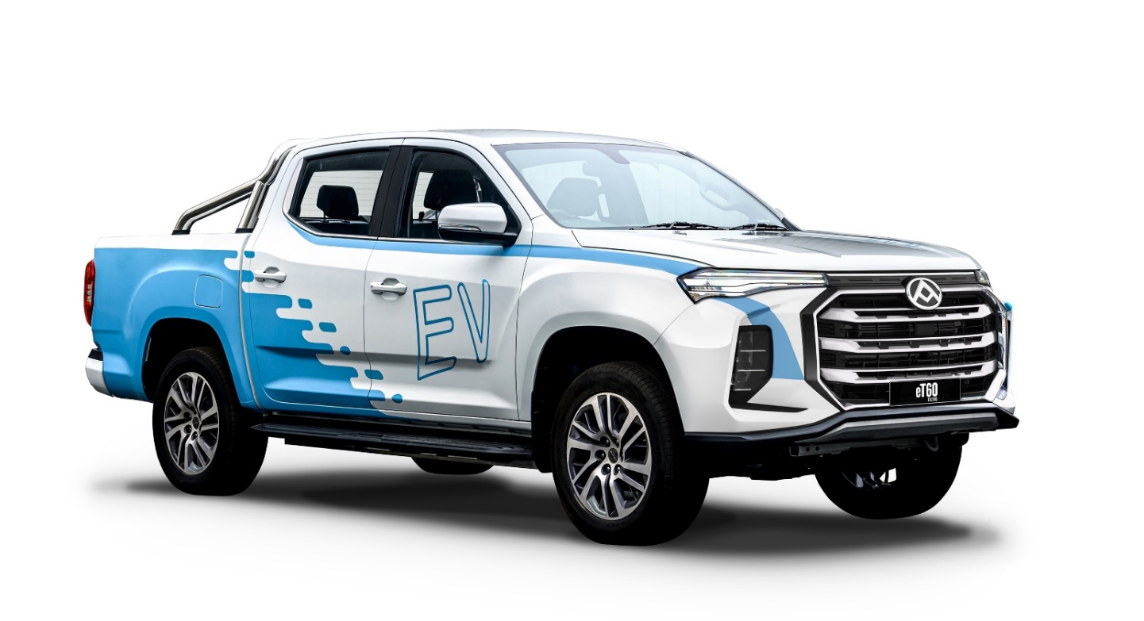

- eT60: Australia’s first electric ute
- eDeliver 9: category-leading large electric van
- Mifa 9: category-leading electric people mover

Sydney, NSW – 29 September 2022

With the automotive market on the threshold of electrification, today marks a significant moment in the history of the LDV brand in Australia, with confirmation of three new electric vehicles arriving November, including a market-first electric ute.

Not since the brand’s launch in 2014 has there been such a fundamental step-change in product strategy. Where once LDV was synonymous with value-driven motoring, now LDV is setting the agenda for commercial electric vehicles in Australia.

LDV is backed by SAIC, one of the world’s largest OEMs with extensive experience as an electric vehicle manufacturer in, arguably, the fastest moving EV market in the world. The new models are: eT60, Australia’s first fully electric ute; eDeliver 9, an electrified version of LDV’s segment-leading large van; and Mifa 9, a luxury electric people mover.

“The global auto market is undergoing its most significant revolution in decades,” says Dinesh Chinnappa, General Manager of LDV Australia.

“Every major OEM is committed to developing electric vehicles, but what is less spoken about is the growing influence of China’s EV market on the rest of the world – and we in Australia are now benefiting from that influence with the arrival of eT60, eDeliver 9 and Mifa 9.

“In the first half of 2022, 2.4 million EVs were delivered to customers in China, more than double the total annual new car market in Australia. EVs now account for 26% of all car sales in China, and 57% of global EV sales. China is moving ahead in electrifying its transport industry and it’s bringing the rest of the world – including Australia – with it.

“So LDV is well-placed to take advantage of this new model EV roll-out, and we’re delighted to share some topline, pre-launch, information with you.”

Headlining this new product onslaught from November 2022 will be the all-new LDV eT60, Australia’s first fully electric ute.

Based on the successful T60 model, which has been embraced by hard-working Australians to the tune of 22,092 since launch, eT60 brings the highly specified, value-focused ute into the EV space.

Offered initially in 4x2 double cab guise, the eT60 is powered by an 88.5kWh lithium-ion battery pack, good for a combined WLTP of 330km^. Charging from 5-100% using an 11kw charger takes approximately 9 hours*, while the eT60’s DC fast-charging capability will charge from 20 to 80% in approximately 45 mins*.

Also to be revealed in November is the LDV eDeliver 9, our first electric large van.

In just two short years its ICE variant, the Deliver 9, has carved out a solid reputation with thousands of Australia fleet owners, to become the number-one selling large van in Australia, delivering 3915 units since launch, resulting in 12.2% market share year to date.

The eDeliver 9 builds on this reputation and will be available in long wheelbase mid- and high-roof variants, along with cab chassis options. The vans are powered by an 88.5kWH lithium-ion battery back and capable of 280km^ (WLTP, based on mid roof model), making the eDeliver 9 the ideal partner in last mile delivery situations.

Charging time for the eDeliver 9 via a 3-phase AC charger takes approximately 9 hours* with a maximum charge rate of 11kw, while DC fast-charging takes approximately 45 minutes* to go from 20-80% charge at a maximum rate of 80kw.

The last of the electric trio to be unveiled in November will be the LDV Mifa 9, a luxury electric people mover.

The MIFA 9 reinvents how to transport up to 7 people in comfort and style with zero tailpipe emissions (an 8-seat model is due early 2023). Yet this futuristic streamline look is achieved without compromise to interior space or practicality.

Arriving in three variants and expected to secure a 5-Star Euro NCAP rating, the MIFA 9 represents the latest in safety innovation including autonomous emergency braking, adaptive cruise control, rear collision warning system, lane departure warning, lane change assist, emergency lane keep assist, electronic stability control and fatigue reminder. It’s a comprehensive technology offer that ensures the Mifa 9 is at the cutting edge of accident-avoidance technology.

Mifa 9 is powered by a 90kWh lithium-ion battery delivering a WLTP combined range of up to 440km^ depending on the variant.

Charging time for the Mifa 9 via an 11kw charger takes approximately 8.5 hours*, while DC fast-charging takes approximately 36 minutes* to charge from 20-80% full.

Full details, specification and pricing of the eT60, eDeliver 9 and Mifa 9 will be revealed during the launch phase in November.

“The Australian auto industry is at a crucial pivot point and embarking on a journey many countries commenced years ago,” says Chinnappa.

“LDV is at the forefront of this journey for commercial vehicles. We have moved from challenger brand to innovator brand. With 92 dealers across the country it’s important we continue to lay the key building blocks for the brand’s future – which is why we’re excited to announce the upcoming arrival of Australia’s first electric ute, eT60, the eDeliver 9 large van, and the Mifa 9 luxury electric people mover. I look forward to sharing more information in November.”

To register your interest, please visit www.ldvautomotive.com.au

ends

* Charging times may vary based on factors including but not limited to charger type and condition, battery temperature, electricity supply, auxiliary consumables (e.g. air-conditioning) and environmental conditions. The time taken for successive rapid charging can take longer if the battery temperature activates the battery safeguarding technology. ^ Range figures are determined by testing under standardised laboratory conditions to comply with ADR 81/ 02. These figures should only be used for the purpose of comparison amongst vehicles. Actual figures will generally differ under real world driving conditions and will vary depending on factors including (but not limited to) driving style, vehicle equipment, and road, traffic and weather conditions.

About LDV
LDV joined SAIC Motor Corporation Limited in 2010, when the latter acquired the commercial vehicles division of the British Motor Corporation, which included the LDV brand. SAIC Motor Corporation Limited (formerly Shanghai Automobile and Industrial Corporation) is the largest automotive manufacturer in China.

A Fortune Global 500 company, SAIC Motor sold over 7 million vehicles in 2019 and has exclusive brands including LDV, Maxus, MG and Roewe. It has also formed joint ventures with Volkswagen and General Motors. Products produced by SAIC Motor joint venture companies are sold under other marques including Buick, Chevrolet, Iveco, Skoda, Volkswagen and Wuling.

SAIC Motor’s business covers the research, production and vehicle sales of both passenger cars and commercial vehicles. It also covers components including engines, gearboxes, powertrains, chassis, interior and exterior and miscellaneous electronic components, and logistics, vehicle telematics, second-hand vehicle transactions and auto finance services.

In Australia since 2014, LDV has a focus on safety, space and value-for-money and continues to innovate with cutting-edge technologies and developments to deliver safe, highly specified, and value-for-money vehicles.

For further information, please contact:
Oliver Peagam
Ateco Group PR Consultant
T: +61 2 8577 8000
E: opeagam@ateco.com.au

